LECTURE 3 - INFORMATION SECURITY POLICY

Policy: IS an essential foundation of effective information security program:
“The success of an information resources protection program depends on the policy generated, and on the attitude of management toward securing information on automated systems.
You, the policy maker, set the tone and the emphasis on how important a role information security will have within your agency.
Your primary responsibility is to set the information resource security policy for the organization with the objectives of reduced risk, compliance with laws and regulations and assurance of operational continuity, information integrity, and confidentiality.”

Why Policy?
A quality information security program begins and ends with policy
Policies are least expensive means of control and often the most difficult to implement
Some basic rules must be followed when shaping a policy:
Never conflict with law
Stand up in court
Properly supported and administered
Contribute to the success of the organization
Involve end users of information systems

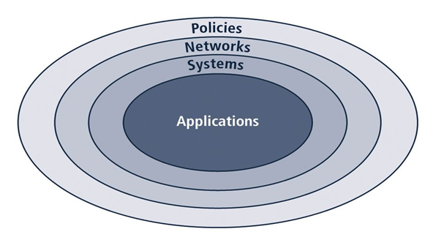
The Bulls-eye Model
Bulls-eye model layers:
- Policies: first layer of defense
- Networks: threats first meet organization’s network
- Systems: computers and manufacturing systems
- Applications: all applications systems

Policies are important reference documents for internal audits and for resolution of legal disputes about management's due diligence. Policy documents can act as a clear statement of management's intent

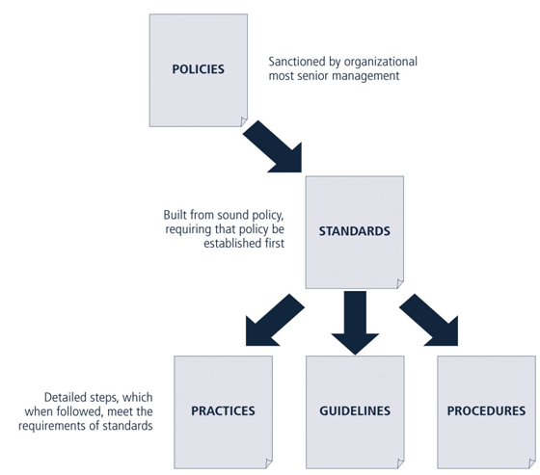
Policies, Standards, & Practices
Policy: plan or course of action that influences and determines decisions
Standards: more detailed statement of what must be done to comply with policy
Practices, procedures and guidelines: explain how employees will comply with policy

For policies to be effective, they must be:
- Properly disseminated
- Read
- Understood
- Agreed-to

Policies require constant modification and maintenance
In order to produce a complete information security policy, management must define three types of information security policy:
- Enterprise information security program policy
- Issue-specific information security policies
- Systems-specific information security policies

Enterprise Information Security Policy (EISP)
Sets strategic direction, scope, and tone for organization’s security efforts
Assigns responsibilities for various areas of information security
Guides development, implementation, and management requirements of information security program

EISP Elements
EISP documents should provide :
- An overview of corporate philosophy on security
- Information about information security organization and information security roles
- Responsibilities for security shared by all members of the organization
- Responsibilities for security unique to each role within the organization

Components of the EISP
- Statement of Purpose: What the policy is for
- Information Technology Security Elements: Defines information security
- Need for Information Technology Security: justifies importance of information security in the organization
- Information Technology Security Responsibilities and Roles: Defines organizational structure
- References Information Technology standards and guidelines

Example EISP - CCW
- Protection Of Information: Information must be protected in a manner commensurate with its sensitivity, value, and criticality
- Use Of Information: Company X information must be used only for business purposes expressly authorized by management
- Information Handling, Access, And Usage: Information is a vital asset and all accesses to, uses of, and processing of Company X information must be consistent with policies and standards
- Data And Program Damage Disclaimers: Company X disclaims any responsibility for loss or damage to data or software that results from its efforts to protect the confidentiality, integrity, and availability of the information handled by computers and communications systems
- Legal Conflicts: Company X information security policies were drafted to meet or exceed the protections found in existing laws and regulations, and any Company X information security policy believed to be in conflict with existing laws or regulations must be promptly reported to Information Security management
- Exceptions To Policies: Exceptions to information security policies exist in rare instances where a risk assessment examining the implications of being out of compliance has been performed, where a standard risk acceptance form has been prepared by the data Owner or management, and where this form has been approved by both Information Security management and Internal Audit management
- Policy Non-Enforcement: Management's non-enforcement of any policy requirement does not constitute its consent
- Violation Of Law: Company X management must seriously consider prosecution for all known violations of the law
- Revocation Of Access Privileges: Company X reserves the right to revoke a user's information technology privileges at any time
- Industry-Specific Information Security Standards: Company X information systems must employ industry-specific information security standards
- Use Of Information Security Policies And Procedures: All Company X information security documentation including, but not limited to, policies, standards, and procedures, must be classified as “Internal Use Only,” unless expressly created for external business processes or partners
- Security Controls Enforceability: All information systems security controls must be enforceable prior to being adopted as a part of standard operating procedure

Issue-Specific Security Policy (ISSP)
- Provides detailed, targeted guidance to instruct organization in secure use of technology systems
- Begins with introduction to fundamental technological philosophy of organization
- Serves to protect employee and organization from inefficiency/ambiguity
- Documents how technology-based system is controlled
- Identifies processes and authorities that provide this control
- Serves to indemnify organization against liability for inappropriate or illegal system use

Every organization’s ISSP should:
- Address specific technology-based systems
- Require frequent updates
- Contain an issue statement on the organization’s position on an issue

Components of the ISSP
Statement of Purpose
- Scope and Applicability
- Definition of Technology Addressed
- Responsibilities
Authorized Access and Usage of Equipment
- User Access
- Fair and Responsible Use
- Protection of Privacy
Prohibited Usage of Equipment
- Disruptive Use or Misuse
- Criminal Use
- Offensive or Harassing Materials
- Copyrighted, Licensed or other Intellectual Property
- Other Restrictions
Systems Management
- Management of Stored Materials
- Employer Monitoring
- Virus Protection
- Physical Security
- Encryption
Violations of Policy
- Procedures for Reporting Violations
- Penalties for Violations
Policy Review and Modification
- Scheduled Review of Policy and Procedures for Modification
Limitations of Liability
- Statements of Liability or Disclaimers

Implementing ISSP
Common approaches:
- Number of independent ISSP documents
- Single comprehensive ISSP document
- Modular ISSP document that unifies policy creation and administration
Recommended approach is modular policy, which provides a balance between issue orientation and policy management

Systems-Specific Policy (SysSP)
- Systems-Specific Policies (SysSPs) frequently do not look like other types of policy
- They may often be created to function as standards or procedures to be used when configuring or maintaining systems
SysSPs can be separated into:
- Management guidance
- Technical specifications
- Combined in a single policy document

Management Guidance SysSPs
- Created by management to guide the implementation and configuration of technology
- Applies to any technology that affects the confidentiality, integrity or availability of information
- Informs technologists of management intent
- Technical Specifications SysSPs
- System administrators directions on implementing managerial policy
- Each type of equipment has its own type of policies

Two general methods of implementing such technical controls:
- Access control lists
- Configuration rules

Access Control Lists
- Include user access lists, matrices, and capability tables that govern rights and privileges
- Can control access to file storage systems, object brokers or other network communications devices
- Capability Table: similar method that specifies which subjects and objects users or groups can access
- Specifications are frequently complex matrices, rather than simple lists or tables
- Level of detail and specificity (often called granularity) may vary from system to system
- ACLs enable administrations to restrict access according to user, computer, time, duration, or even a particular file

ACLs
In general ACLs regulate:
- Who can use the system
- What authorized users can access
- When authorized users can access the system
- Where authorized users can access the system from
- How authorized users can access the system
- Restricting what users can access, e.g. printers, files, communications, and applications
Administrators set user privileges, such as:

- Read
- Write
- Create
- Modify
- Delete
- Compare
- Copy

Configuration Rules
Configuration rules are specific configuration codes entered into security systems to guide execution of system when information is passing through it
Rule policies are more specific to system operation than ACLs and may or may not deal with users directly
Many security systems require specific configuration scripts telling systems what actions to perform on each set of information processed

Combination SysSPs
- Often organizations create a single document combining elements of both Management Guidance and Technical Specifications SysSPs
- While this can be confusing, it is very practical
- Care should be taken to articulate required actions carefully as procedures are presented

Guidelines for Policy Development
It is often useful to view policy development as a two-part project
- Design and develop policy (or redesign and rewrite outdated policy)
- Establish management processes to perpetuate policy within organization

The Policy Project
- Policy development or re-development projects should be well planned, properly funded, and aggressively managed to ensure completion on time and within budget
- When a policy development project is undertaken, the project can be guided by the SecSDLC process
Investigation Phase
- The policy development team should:
- Obtain support from senior management, and active involvement of IT management, specifically CIO
- Clearly articulate goals of policy project
- Gain participation of correct individuals affected by recommended policies
- Be composed from Legal, Human Resources and end-users
- Assign project champion with sufficient stature and prestige
- Acquire a capable project manager
- Develop detailed outline of and sound estimates for the cost and scheduling of the project
Analysis Phase
Analysis phase should include the following activities:
- New or recent risk assessment or IT audit documenting the current information security needs of the organization
- Key reference materials—including any existing policies

Design Phase
Design phase should include:
- How policies will be distributed
- How verification of distribution will be accomplished
- Specifications for any automated tools
- Revisions to feasibility analysis reports based on improved costs and benefits as design is clarified

Implementation Phase
- Implementation Phase: writing the policies
- Make certain policies are enforceable as written
- Policy distribution is not always as straightforward
- Effective policy
- Is written at a reasonable reading level
- Attempts to minimize technical jargon and management terminology

Maintenance Phase
- Maintain and modify policy as needed to ensure that it remains effective as a tool to meet changing threats
- Policy should have a built-in mechanism via which users can report problems with the policy, preferably anonymously
- Periodic review should be built in to the process

The Information Security Policy Made Easy Approach (ISPME)
- Gathering Key Reference Materials
- Defining A Framework For Policies
- Preparing A Coverage Matrix
- Making Critical Systems Design Decisions
- Structuring Review, Approval, And Enforcement Processes
Coverage Matrix
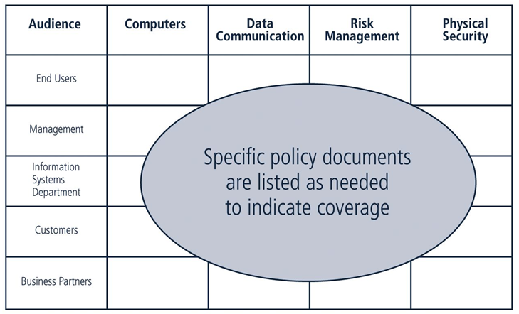

Guide for Developing Security Plans
- Policies:
Living documents that constantly change and grow
Must be properly disseminated (distributed, read, understood and agreed to) and managed
- Good management practices for policy development and maintenance make for a more resilient organization
In order to remain current and viable, policies must have:
- Individual responsible for reviews
- Schedule of reviews
- Method for making recommendations for reviews
- Indication of policy and revision date

Policies exist first, and foremost, to inform employees of what is and is not acceptable behavior in the organization
Policy seeks to improve employee productivity, and prevent potentially embarrassing situations

